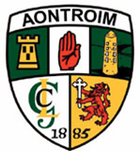
An Chomdhail Bhliantuil 2013
Convention Timetable

7th October | Existing Members to indicate willingness for re election
9th October | Issue Nomination Papers & Motion / Recommendations.
9th October | Issue request for Committee reports for convention Booklet
25th October | Cutoff date for return of Nomination papers. & M / R.
31st October | Notify Nominated persons.
31st October | Cutoff date for receipt of committee reports
4th November | Cutoff date for acceptance of Nomination
8th November | Printing Convention Booklets.
25th November | Distribution of Convention Booklets
9th December | County Convention, Dunsilly Hotel, Antrim @ 7.30pm

